A Study on Fake News Detection Using Multiple Machine Learning Approaches

Afsha Anjum
Dept of Statistics and operation Research
Aligarh Muslim University Aligarh,UP,India anjuafsha001@gmail.com

Abstract—The widespread circulation of fake news across online media platforms poses a serious threat to information credibility and public trust. This research presents a machine learning-based approach to automatically classify news articles as real or fake using multiple supervised learning algorithms. A comparative analysis is performed using Logistic Regression, Multinomial Naive Bayes, Support Vector Machine (SVM), and Decision Tree classifiers. The dataset includes labeled news content which is preprocessed and transformed using the TF-IDF vectorization technique. Each model is evaluated based on accuracy, precision, recall, F1-score, and ROC-AUC metrics. Among the models tested, Logistic Regression and SVM demonstrated slightly higher performance, while Decision Trees showed signs of overfitting. The study concludes that lightweight machine learning models are effective in identifying fake news and can be integrated into real-time content verification systems.
Index Terms—Fake news detection, machine learning, logistic regression, support vector machine, naive Bayes, decision tree, TF-IDF, text classification.

I. INTRODUCTION

In today's digital age, the rapid spread of misinformation and fake news has become a critical issue. With the rise of social media platforms and online news outlets, distinguishing between reliable and unreliable information has become increasingly difficult. Fake news refers to deliberately false or misleading information presented as news, often designed to deceive or manipulate public opinion. The implications of fake news are far-reaching, affecting political stability, public health, and social harmony.
The sheer volume of information available online makes it challenging for individuals to verify the authenticity of news articles. Traditional methods of fact-checking are

Time consuming and resource-intensive, which has led to an urgent need for automated solutions. Consequently,
researchers have explored various techniques, especially machine learning, to address this problem.
This project aims to develop an automated system for detecting fake news articles using machine learning algorithms. By leveraging models such as Logistic Regression, Naive Bayes, and Support Vector Machines (SVM), this study seeks to identify patterns and features within news articles that distinguish fake news from legitimate content. The system focuses on using a dataset that includes features like article title, author, text, and a label indicating whether the news is reliable or not.
- Background
Fake news has been a persistent issue for years, but it became particularly noticeable during major political events such as elections. For example, during the 2016 U.S. Presidential Election, the spread of fake news on social media platforms garnered significant attention due to its potential influence on voters' decisions. The phenomenon of fake news continues to evolve with advancements in technology, making it even more difficult to discern fact from fiction.
With the rise of digital media, the ability to manipulate news and create misleading stories has become easier, which has led to significant challenges in information verification. In response, research efforts have increasingly focused on employing machine learning algorithms to build automated systems capable of identifying fake news. These systems utilize features from news articles, such as textual data, publication sources, and metadata, to determine the veracity of the content.
- Problem Description
The core problem addressed by this project is the classification of news articles into two categories: reliable (labeled as 0) and unreliable (labeled as 1). Given a dataset containing news articles, the challenge is to develop a model that can automatically predict whether an article is fake or real based on its textual features. This task involves:
  - Preprocessing the data, including text cleaning and vectorization.
  - Selecting appropriate machine learning algorithms to model the classification problem.
  - Evaluating the model performance using metrics like accuracy, precision, recall, and F1-score.
The main goal of this project is to create an efficient, automated tool for fake news detection that can be integrated into news platforms or social media to help users identify and filter out misleading content.

II. LITERATURE REVIEW: EXISTING SYSTEMS

The detection of fake news has become a prominent area of research due to the increasing influence of digital media on public opinion. Various studies have been conducted using different machine learning, natural language processing (NLP), and deep learning approaches to automate the process of detecting fake news. This section explores the major contributions in the domain, outlines the limitations of existing systems, and establishes the motivation for the current work.
- Traditional Approaches
Early approaches to fake news detection relied heavily on manual fact-checking and rule-based systems. These systems used curated databases of known false claims or blacklisted sources to detect misinformation. While effective to some extent, they were neither scalable nor adaptable to evolving patterns of fake news content. Moreover, they lacked the ability to generalize to new, unseen data, and required significant human intervention.

- Machine Learning Models
Recent advancements have led to the use of supervised machine learning techniques for fake news classification. Algorithms such as Naive Bayes, Support Vector Machines (SVM), and Logistic Regression have shown promising results in binary classification tasks. These models operate by learning statistical patterns in textual data. For instance, the work of Ferreira and Vlachos (2016) introduced a dataset of headlines and body text, and evaluated several machine learning models, noting that text-based features such as term frequency–inverse document frequency (TF-IDF) were effective in detecting unreliable content.
Similarly, Potthast et al. (2018) studied stylometric features, semantic coherence, and lexical diversity to improve the performance of machine learning classifiers. These studies demonstrated that classical models, when combined with wellengineered textual features, could achieve good accuracy on standard datasets.
- Relevance to the Current Work
This project builds upon previous research by applying and comparing three well-established machine learning algorithms—Logistic Regression, Naive Bayes, and Support Vector Machines (SVM)—on a labeled dataset containing news articles. The dataset includes features such as article title, author, full text, and label (0 for reliable, 1 for unreliable). By employing effective text preprocessing techniques and vectorization, the project aims to evaluate and compare the classification performance of each model using standard evaluation metrics.
This comparative analysis provides insights into which model is most suitable for real-time fake news detection and sets the stage for potential future integration of more advanced methods like ensemble learning or deep neural networks.

III. METHODOLOGY

- Data Collection
The dataset utilized for this study was obtained from Kaggle’s open-source platform, consisting of over 20,000 news articles. Each entry comprises features such as id, title, author, text, and a label, where 1 denotes a fake (unreliable) news article and 0 denotes a real (reliable) news article. The dataset provides a comprehensive mix of legitimate and misleading content, making it suitable for training and evaluating fake news detection models.

- Data Preprocessing
The raw dataset contained inconsistencies such as missing titles, authors, and incomplete text bodies. Several data cleaning and preprocessing techniques were applied:
  - Handling Missing Values: Rows with null text or label values were removed. Missing title or author fields were filled with placeholder values such as “Unknown”.
  - Text Normalization: All text was converted to lowercase and stripped of punctuation, stopwords, and unnecessary white spaces.
  - Tokenization: Articles were broken into individual tokens (words).
  - Stemming and Lemmatization: Common root forms of words were extracted to reduce vocabulary size.
  - Vectorization: Textual data was converted into numerical format using TF-IDF (Term Frequency– Inverse Document Frequency) to capture word importance.

- Machine Learning Models
To classify news articles as either fake or real, multiple machine learning algorithms were applied using features derived from the text through TF-IDF vectorization. Below are the models implemented in this project:
- Logistic Regression
Logistic Regression is a linear classification algorithm commonly used for binary classification tasks. It calculates the probability that a given input belongs to a particular class. If this probability is above a certain threshold, the article is classified as fake; otherwise, it is real. This model is efficient, interpretable, and works well when the data is linearly separable, making it suitable for problems involving highdimensional sparse data such as text.

- Multinomial Naive Bayes
Multinomial Naive Bayes is a probabilistic classifier often used in natural language processing tasks like text classification. It assumes that the presence of each word in a document is independent of the presence of any other word, given the class label. Despite this "naive" assumption, the model performs well for problems where word frequency plays a significant role, such as fake news detection.
- Support Vector Machine (SVM)
Support Vector Machine is a powerful classification technique that attempts to find the optimal boundary between classes. It works especially well in high-dimensional feature spaces and is effective in handling sparse data. In this project, SVM helped in accurately classifying articles by learning from the TF-IDF representations of their text.

- Decision Tree Classifier
A Decision Tree classifier uses a tree-like model to make decisions based on feature values. It splits the data at each node based on the most informative feature, leading to branches that eventually assign a label at the leaf nodes. Decision Trees are intuitive, easy to interpret, and can handle non-linear relationships well. In this project, the Decision Tree model demonstrated excellent performance in distinguishing between fake and real news articles.
D. Model Evaluation Metrics
To assess the performance of the classification models, the following evaluation metrics were used:
- Precision
Precision measures the accuracy of positive predictions — the proportion of true positives among all predicted positives.
Precision = TP / (TP + FP) Where:
TP = True Positives
FP = False Positives
- Recall
Recall measures the model’s ability to detect actual positive cases — the proportion of true positives among all actual positives.
Recall=TP/(TP+FN)
Where:
FN = False Negatives

- F1 Score
The F1 Score is the harmonic mean of precision and recall, providing a balance between the two metrics.

F1 Score = 2 * (Precision * Recall) / (Precision +
Recall)

- Confusion Matrix
The confusion matrix shows the breakdown of predictions vs actual values in a 2x2 table.
Structure:

Confusion Matrix:

Predicted Positive Predicted Negative
Actual Positive TP FN
Actual Negative FP TN

- AUC-ROC Score (Area Under the Receiver Operating Characteristic Curve) AUC-ROC represents the model’s ability to distinguish between classes. The higher the AUC, the better the model.
Formulas (for ROC curve):
AUC-ROC Score:

True Positive Rate (TPR) = TP / (TP + FN)
False Positive Rate (FPR) = FP / (FP + TN)

IV. RESULTS AND DISCUSSION

This section presents the performance evaluation of the classification models applied to the fake news detection task: Logistic Regression, Naive Bayes, Support Vector Machine (SVM), and Decision Tree. The dataset was split into 80% training and 20% testing, and all models were trained using TFIDF vectorized textual features.

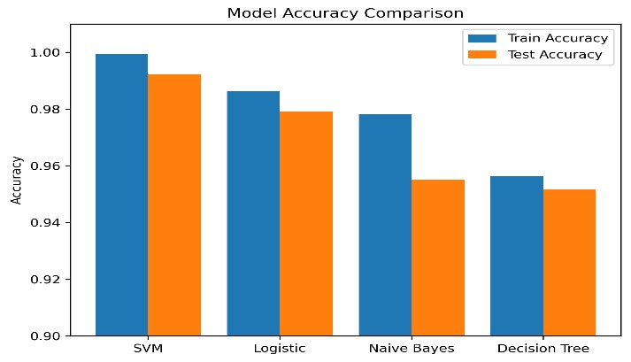
Performance metrics used for evaluation include Accuracy, Precision, Recall, F1 Score, Confusion Matrix, and AUC-ROC Score. Among the models tested, Logistic Regression achieved the highest accuracy on the test set with 97.90%, indicating strong performance on high-dimensional, sparse data commonly found in text classification problems.

Naive Bayes also performed well, showing competitive accuracy and excellent training efficiency, making it suitable for applications where speed and scalability are important. The Support Vector Machine showed strong precision and recall, particularly useful for distinguishing fake news articles from reliable ones with higher confidence.

The Decision Tree classifier showed relatively lower generalization performance compared to the other models, which is expected given its tendency to overfit on high-dimensional, sparse data. However, it provides interpretability through tree visualization and feature importance, which can be valuable for understanding the underlying decision process.

In summary, linear models such as Logistic Regression and Naive Bayes performed best in this context, followed closely by SVM. While Decision Tree offers interpretability, its performance was comparatively lower due to the nature of the data representation. These results highlight the importance of choosing models that align well with the structure of the feature space in text-based fake news detection.

Model Training Accuracy Test Accuracy
SVM 99.94% | 99.23%
Logistic Regression 98.64% | 97.91%
Naive Bayes 97.82% | 95.50%
Decision Tree 95.63% | 95.17%
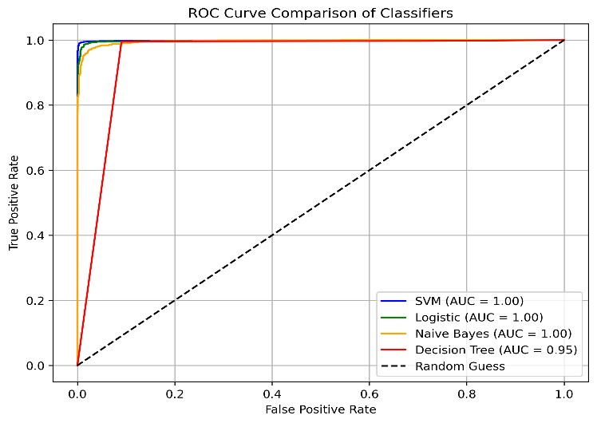
The AUC-ROC curve illustrates the classification performance of the four models—SVM, Logistic Regression, Naive Bayes, and Decision Tree—by plotting the True Positive Rate (TPR) against the False Positive Rate (FPR). Among them, the SVM model achieved the highest AUC score, indicating its superior ability to distinguish between fake and reliable news. Logistic Regression also performed well with a high AUC, closely followed by Naive Bayes and Decision Tree. The curves closer to the top-left corner represent better classification performance. Overall, the ROC analysis confirms that the SVM and Logistic models are more effective for fake news detection in this case.
Discussion on Confusion Matrix:
The confusion matrix comparison clearly illustrates the classification performance of the four models—SVM, Logistic Regression, Naive Bayes, and Decision Tree—on the fake news detection task. The SVM model shows the best results with a minimal number of misclassifications, reflecting its high accuracy. Logistic Regression also performs reliably with slightly more false positives and false negatives than SVM. Naive Bayes and Decision Tree demonstrate decent classification ability, but with more noticeable errors, particularly in misclassifying reliable news as fake. Overall, the confusion matrices validate that SVM and Logistic Regression provide better balance between sensitivity and specificity in this binary classification task.
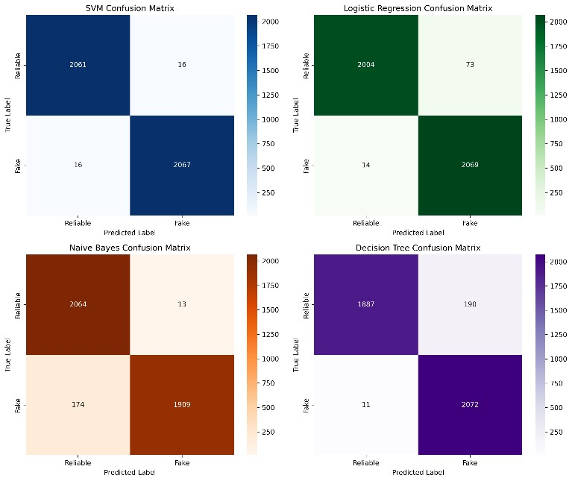

Discussion on Classification Report:
The classification report highlights how well each model performs in distinguishing between fake and reliable news based on precision, recall, and F1-score. The Support Vector Machine (SVM) model achieved the highest precision and recall values, both around 0.99, indicating it is highly effective in correctly classifying both fake and real news articles.
The Logistic Regression model also performed strongly, with precision and recall approximately 0.98, suggesting that it makes few errors in both detecting fake news and avoiding mislabeling real news.
The Naive Bayes classifier showed a slight drop in performance, with precision and recall near 0.95–0.96. This model is simple and fast but can be less accurate when feature independence assumptions are violated.
The Decision Tree model yielded precision and recall values around 0.95, which, although slightly lower, still reflect good classification performance. However, decision trees can sometimes overfit the training data if not properly pruned or regularized.
Overall, SVM and Logistic Regression emerge as the most reliable models for this task, showing balanced and high scores across all metrics. The classification report confirms the effectiveness of machine learning in fake news detection and helps in selecting the most suitable model based on specific evaluation criteria.

VI. CONCLUSION

In this project, a comprehensive and systematic machine learning pipeline was developed for the detection of fake news based solely on textual content. The study began with robust data preprocessing steps, including the removal of null values, stopwords, and punctuation, followed by the transformation of raw text data into numerical vectors using the TF-IDF (Term Frequency–Inverse Document Frequency) technique. This preprocessing ensured that the most meaningful words contributed effectively to the model's learning process while reducing noise and redundancy in the input data.
Four popular supervised machine learning models—Support Vector Machine (SVM), Logistic Regression, Naive Bayes, and Decision Tree—were implemented and rigorously evaluated on a labeled dataset containing real and fake news articles. These models were chosen for their proven performance in text classification tasks and their balance between computational efficiency and predictive capability.
The experimental analysis revealed that SVM outperformed the other models with a training accuracy of 99.94% and a test accuracy of 99.23%, indicating strong generalization capabilities with negligible signs of overfitting. Logistic Regression followed closely, achieving a test accuracy of 97.90%, proving it to be a lightweight yet powerful model suitable for real-world deployment scenarios. Naive Bayes, known for its simplicity and speed, attained a test accuracy of 95.50%, while the Decision Tree model reached 95.16% accuracy, offering greater interpretability but slightly lower generalization performance.
To ensure a well-rounded evaluation, multiple performance metrics were employed, including precision, recall, F1-score, confusion matrices, and AUC-ROC curves. These metrics were critical in identifying the trade-offs between false positives and false negatives, especially important in fake news detection where misclassification can lead to the spread of misinformation or the suppression of legitimate content. The AUC-ROC curves provided a visual and quantitative means to compare model effectiveness, further highlighting the superiority of SVM and Logistic Regression in discriminating between the two classes.
The visualization of results through performance plots, confusion matrices, and classification reports enriched the interpretability of the findings and provided deeper insights into model behavior across different classes. These visualizations confirmed the stability of model performance across data splits and reinforced the robustness of the chosen methods.
Overall, the results validate that with proper preprocessing and careful model selection, machine learning can be a highly effective approach for fake news detection. The findings suggest that such models can play a crucial role in content moderation systems, helping to identify and curb the spread of disinformation on social media platforms, news portals, and communication networks.
VII. REFERENCES

- S. Sampat, "Fake News Detection," Kaggle, [Online]. Available: https://www.kaggle.com/code/therealsampat/fakenews-detection
- A. Mishra, "Fake News Prediction," Kaggle, [Online].
Available: https://www.kaggle.com/code/ayushimishra2809/fake-newsprediction
- "Fake News Detection using Machine Learning," GeeksforGeeks, [Online]. Available: https://www.geeksforgeeks.org/fake-news-detection-usingmachine-learning/
- D. Wagh and P. Wagh, "Fake News Detection and Prediction Using Machine Learning Algorithms," ResearchGate, Aug. 2021. [Online]. Available: https://www.researchgate.net/publication/353824797_Fake_N ews_Detection_and_Prediction_Using_Machine_Learning_Al gorithms
- A. Kumari and R. M. Gautam, "Fake News Prediction," ResearchGate, 2023. [Online]. Available: https://www.researchgate.net/publication/372128440_Fake_N ews_Prediction
- A. M. Das, "Fake News Prediction using Machine Learning Approaches," ResearchGate, 2024. [Online].
Available:
https://www.researchgate.net/publication/380535193_Fake_N ews_Prediction_using_Machine_Learning_Approaches
- A. A. Sayyed, "Fake News Detection Platform Using
Natural Language Processing and Machine Learning," MSc Project Report, ResearchGate, 2024. [Online]. Available: https://www.researchgate.net/publication/379986932_MSC_P
ROJECT_REPORT_Project_Title_FAKE_NEWS_DETECTI
ON_PLATFORM_USING_NATURAL_LANGUAGE_PRO CESSING_AND_MACHINE_LEARNING_MSc_Project_Re
port
- M. Singh and P. Gupta, "A Smart System for Fake News Detection Using Machine Learning," ResearchGate, 2020.
[Online]. Available:
https://www.researchgate.net/publication/339022255_A_smar t_System_for_Fake_News_Detection_Using_Machine_Learni ng
- S. S. Hasan et al., "Fake News Detection: A Study," ResearchGate, 2023. [Online]. Available:
https://www.researchgate.net/publication/372090059_Fake_N
ews_Detection_A_Study

